SME program example

SAB Foundation (Tholoana Enterprise Programme)
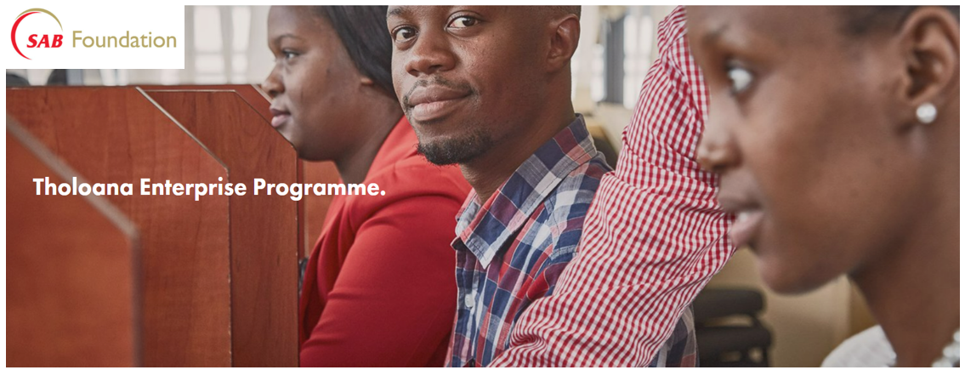
Set up in 2010 as one element of the broad-based black economic empowerment transaction conducted by South African Breweries Ltd (SAB), the SAB Foundation is an independent trust that annually invests millions of rands towards developing entrepreneurship in South Africa. The foundation strives to achieve its objective mainly through providing funding for SME’s primarily through a number of programmes offered by the foundation.
The foundation has a number of different programmes which can be found on their website. The Tholoana Enterprise Programme being one of their flagship programmes which supports entrepreneurs to become successful and resilient business owners through extensive entrepreneurial skills development, mentorship and access to markets, finance and practical business tools and templates.
With this programme, the foundation aims to invest in entrepreneurs – with a particular emphasis on women, youth, people in rural areas and entrepreneurs with a disability – who show the potential and commitment to grow a business and create jobs. This is done through a structured, two-year business support programme, seed-funding and assisting with access to markets.
Applications open once a year with the businesses showing the most potential and commitment with about 60 new entrepreneurs being brought onto the programme per annum.

Application link:
https://sab.praxisgms.co.za/xaLogin/SAB/regLogin.aspx?ReturnUrl=%2Fdefault.aspx

Application guide:
Microsoft Word - 2023 Social Innovation Online Application Guidance Document.docx (squarespace.com)

Elligibility criteria:
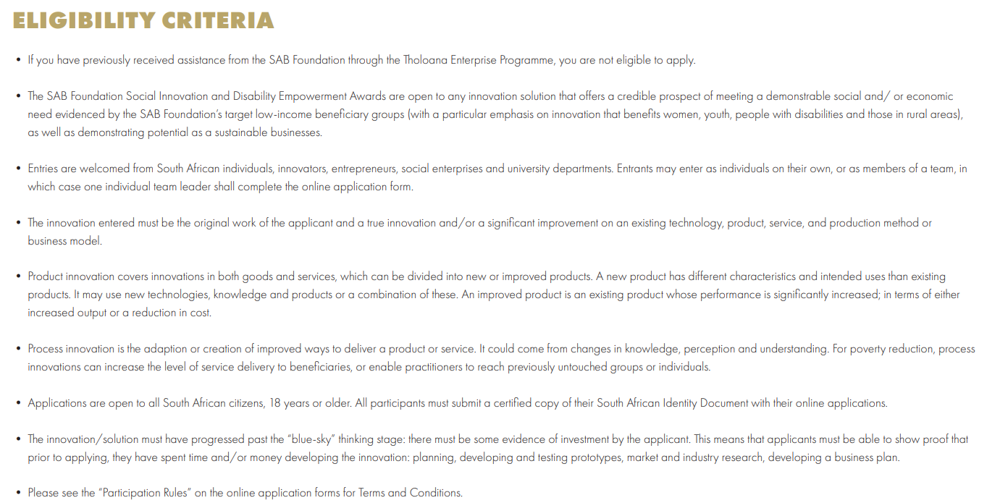

How to apply:
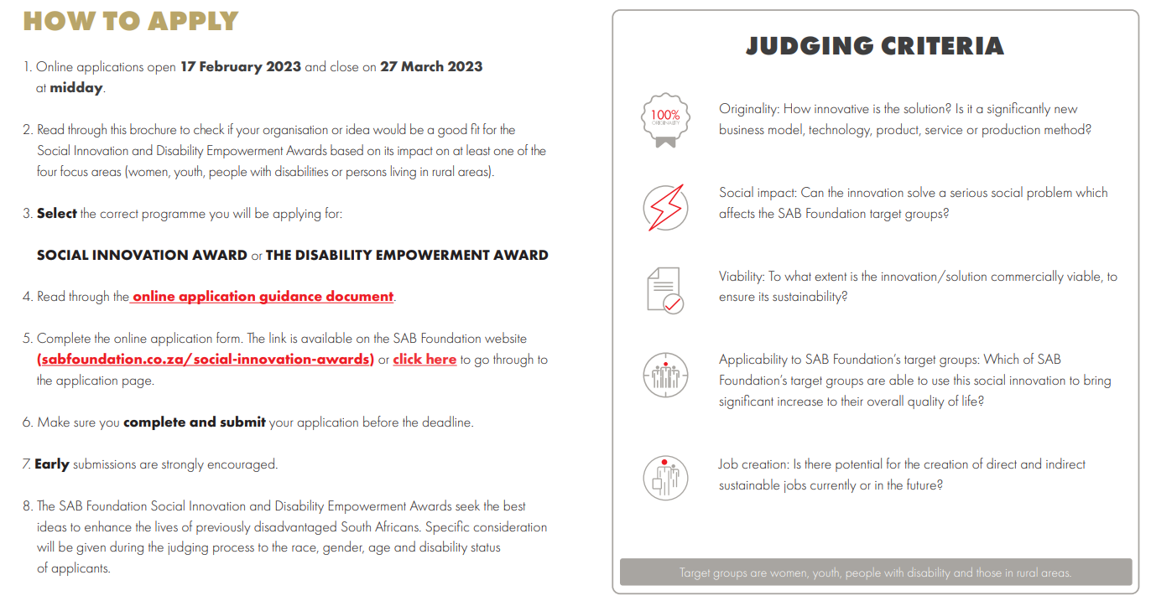

Timeline:
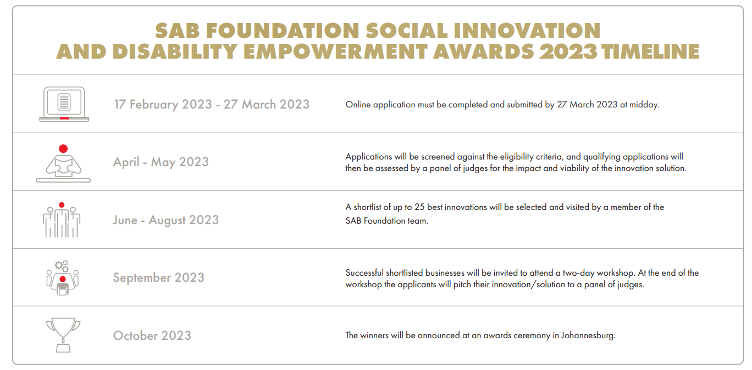
Source: SAB+SIA+2023+-+Applications+Open+-+Digital+Brochure.pdf (squarespace.com)
Scan below to access Social Media platform of SAB Foundation.
